Week 2 - Day 3 – Project 1 (Windows IIS)

Windows Instance

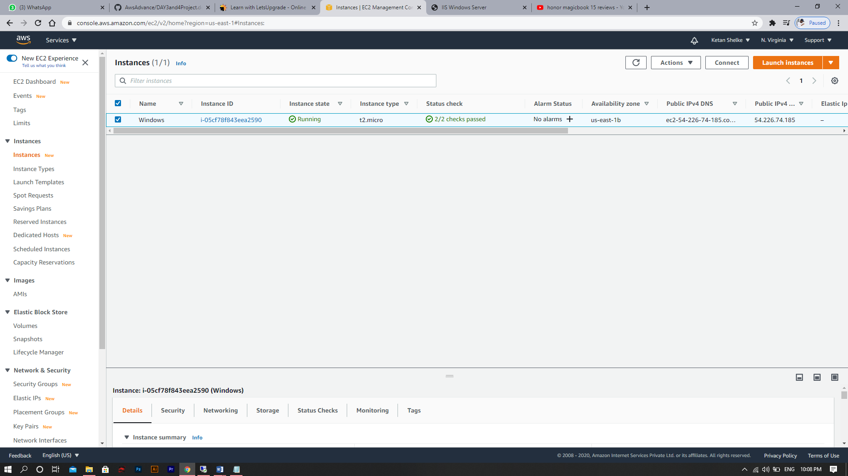

Windows IIS Server

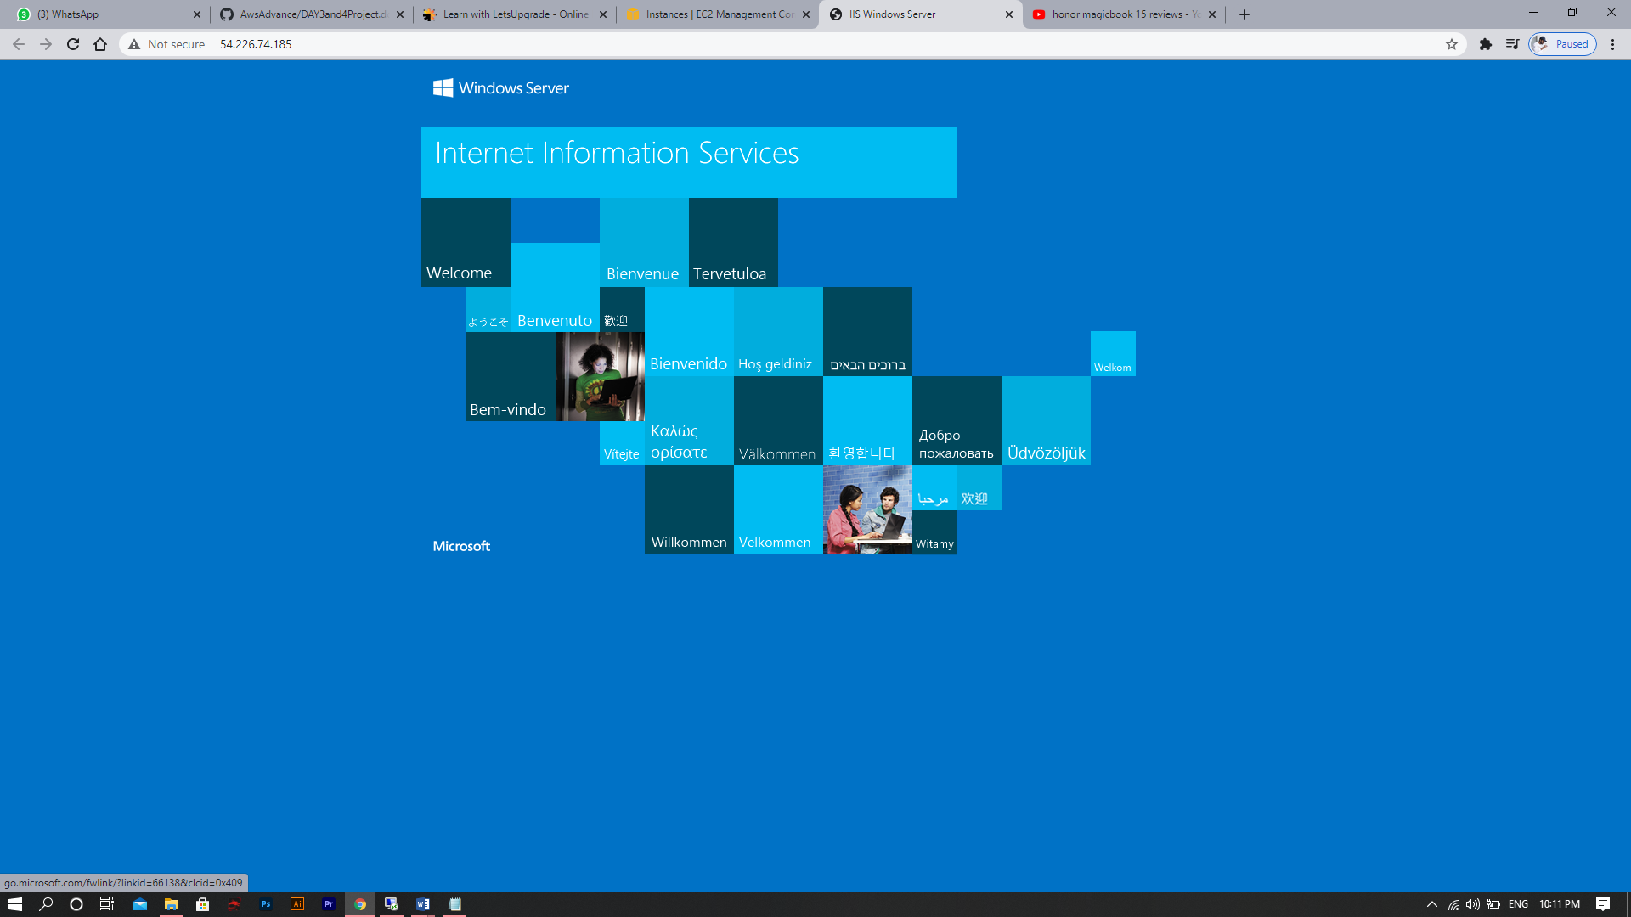

Week 2 - Day 3 – Project 2 (Nginx)

Deploying ubuntu Instance

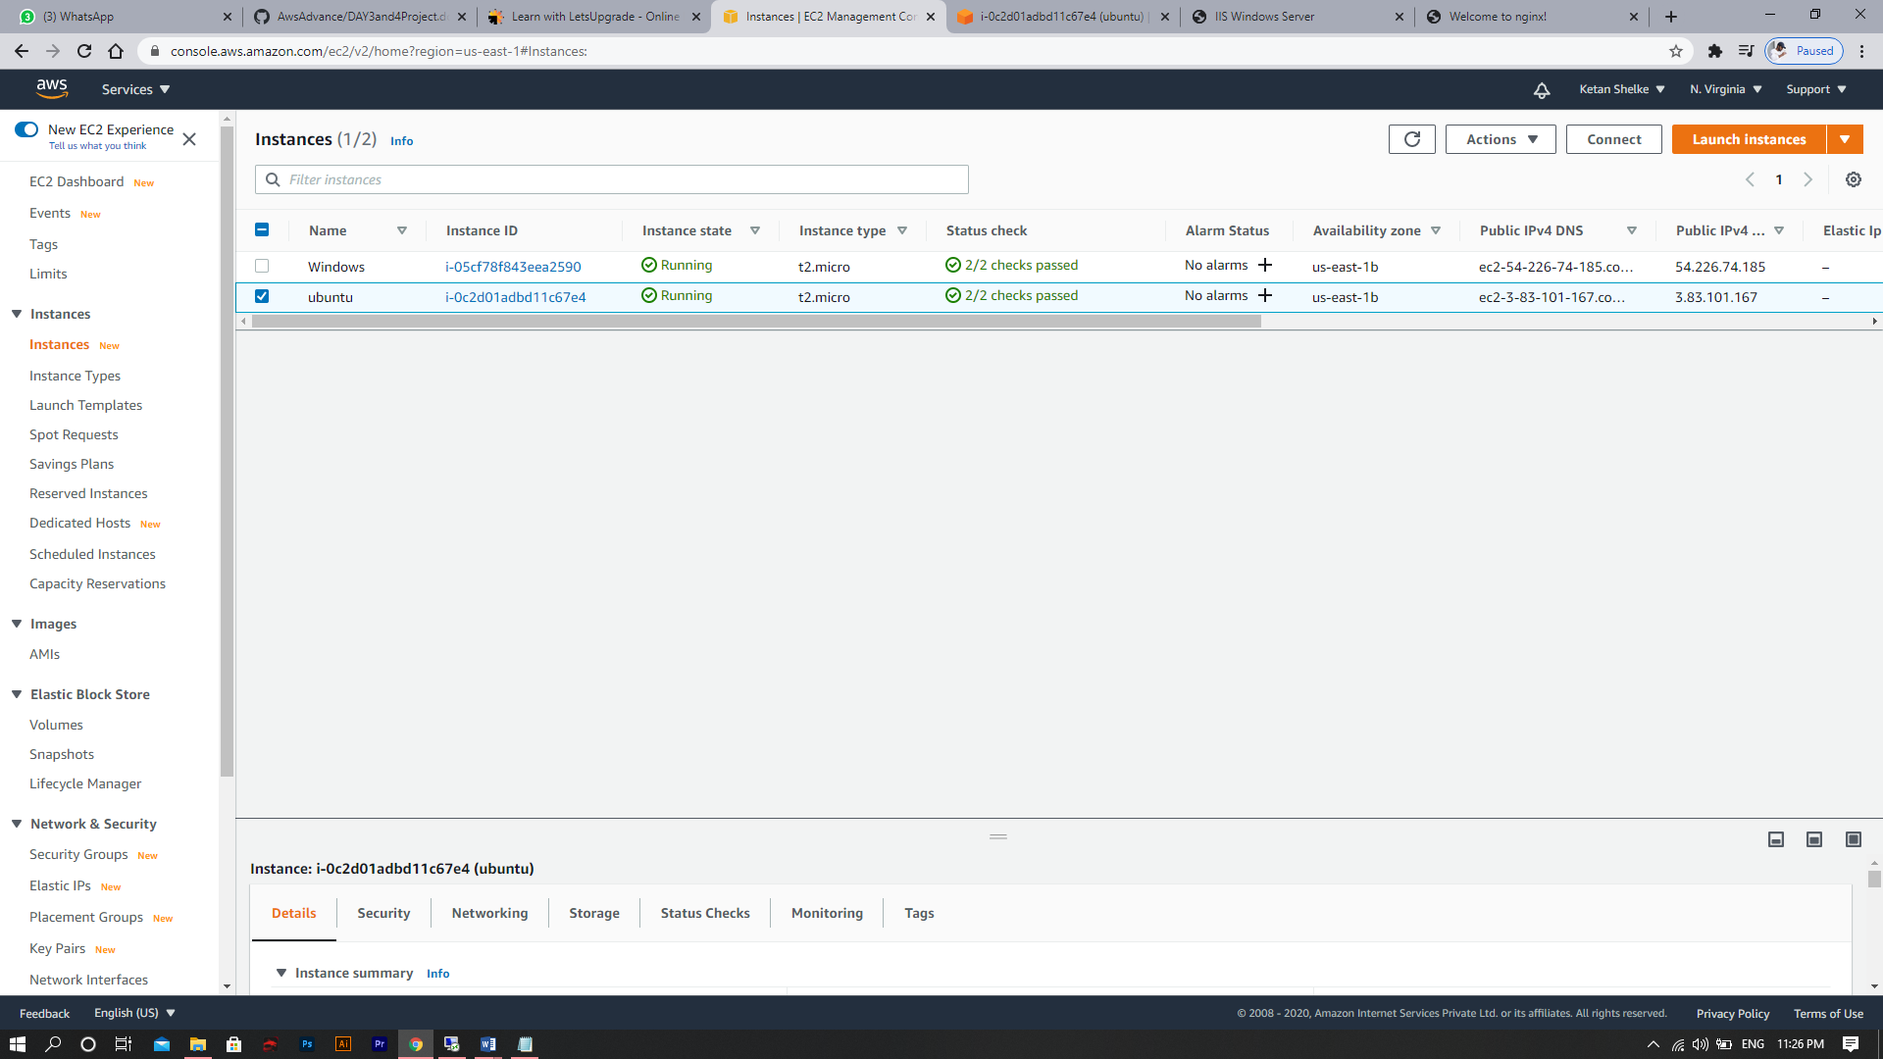

Installation of Ubuntu Server

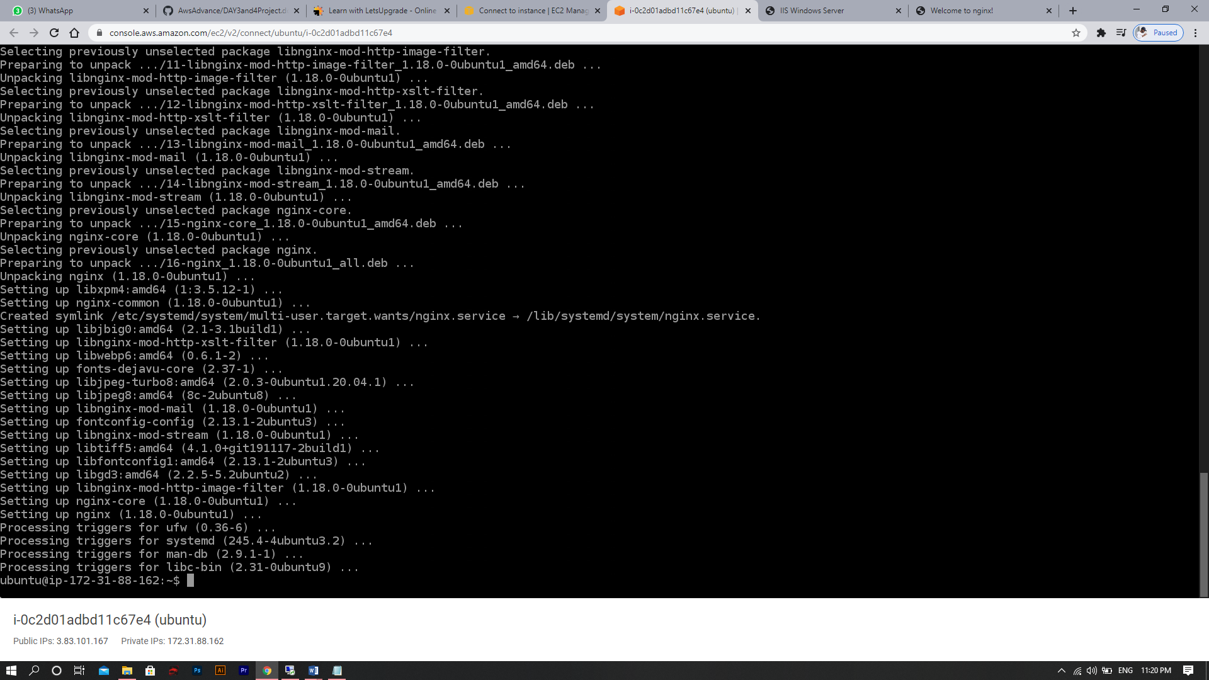

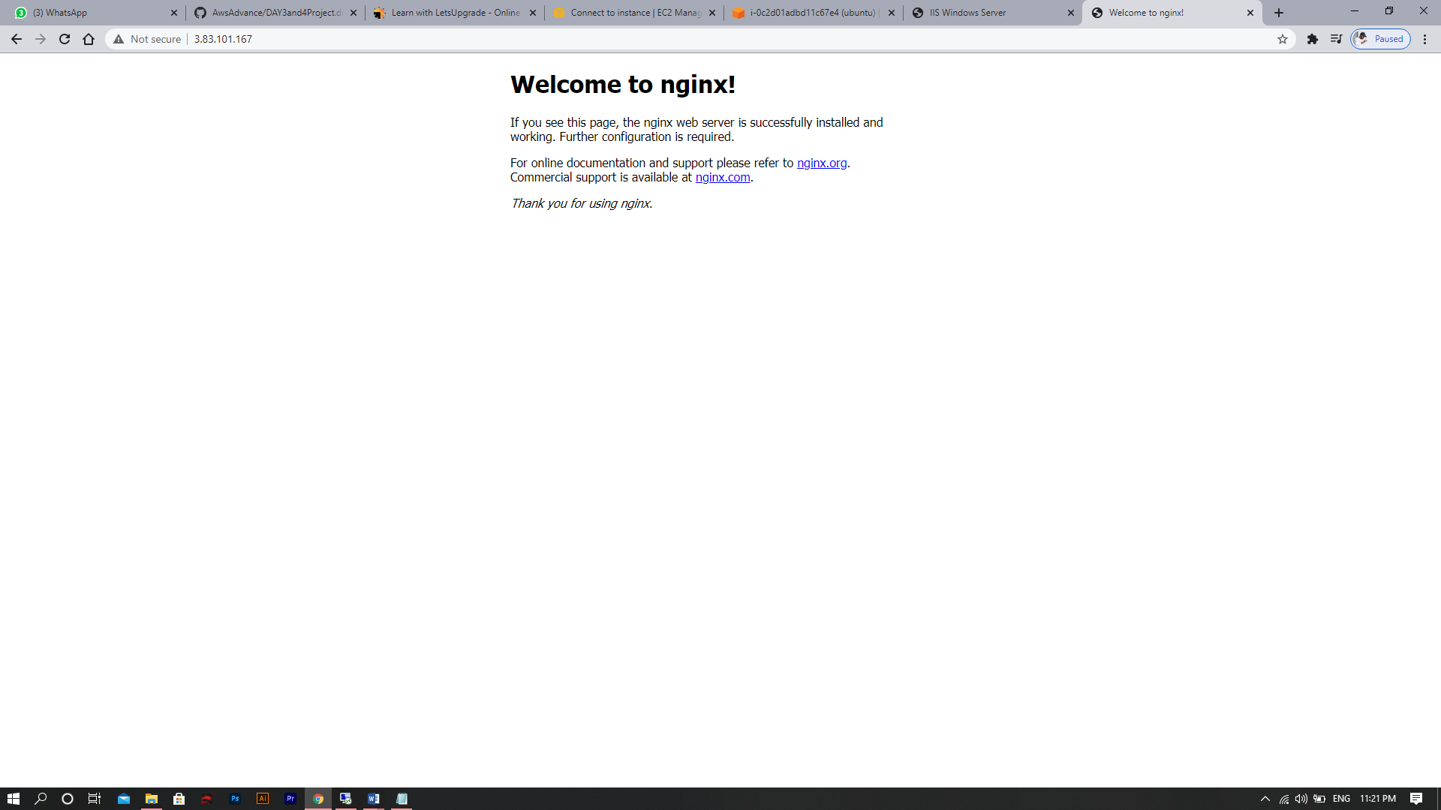

Week 2 - Day 3 – Project 3 (EBS Volume)

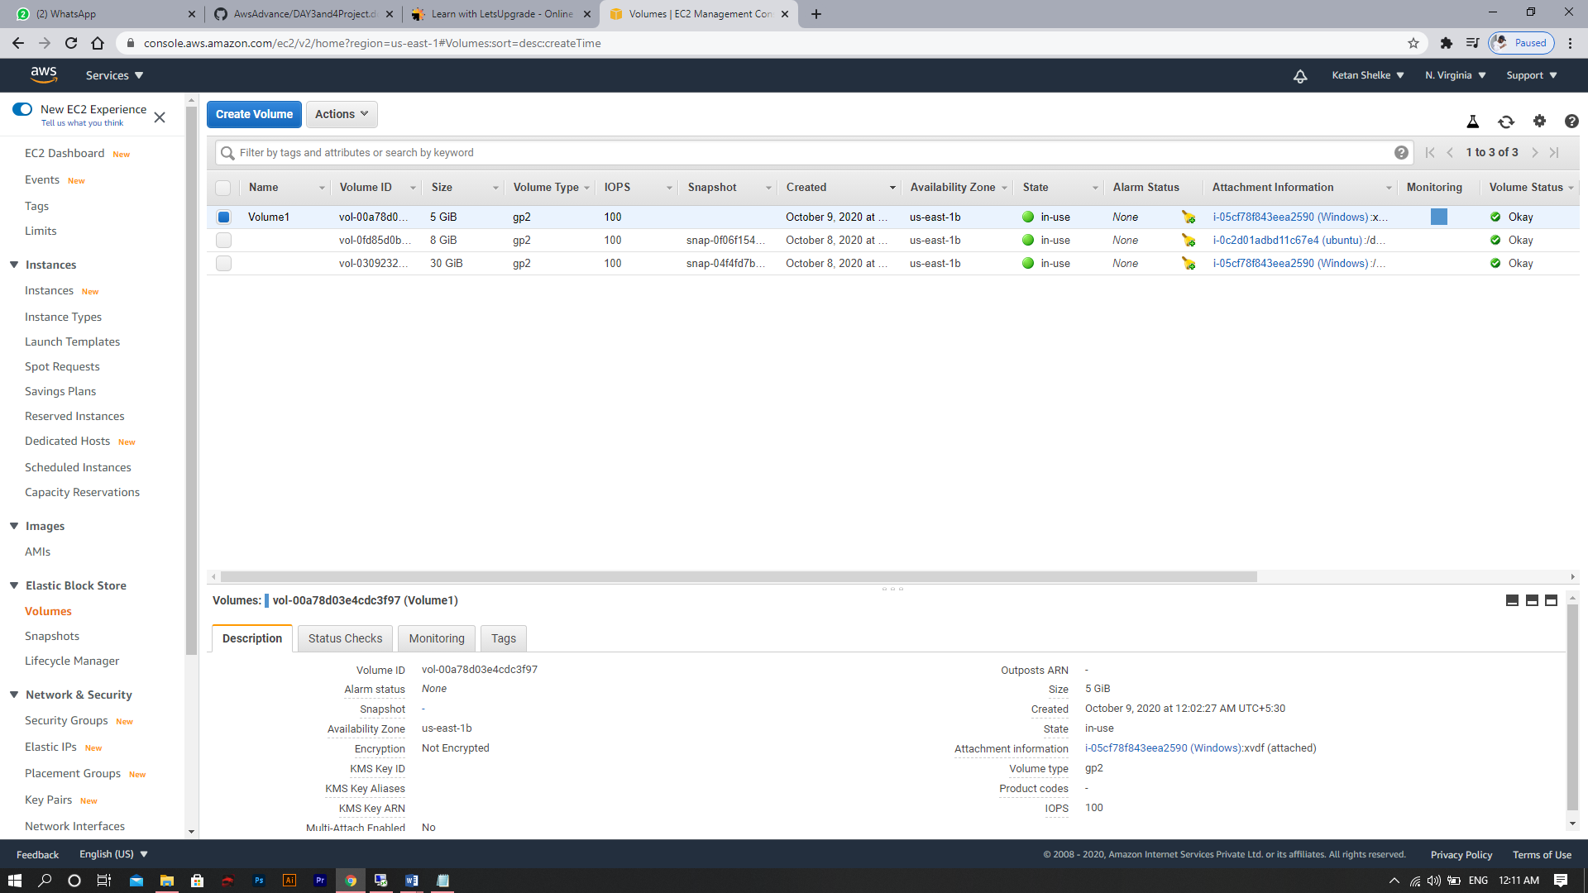

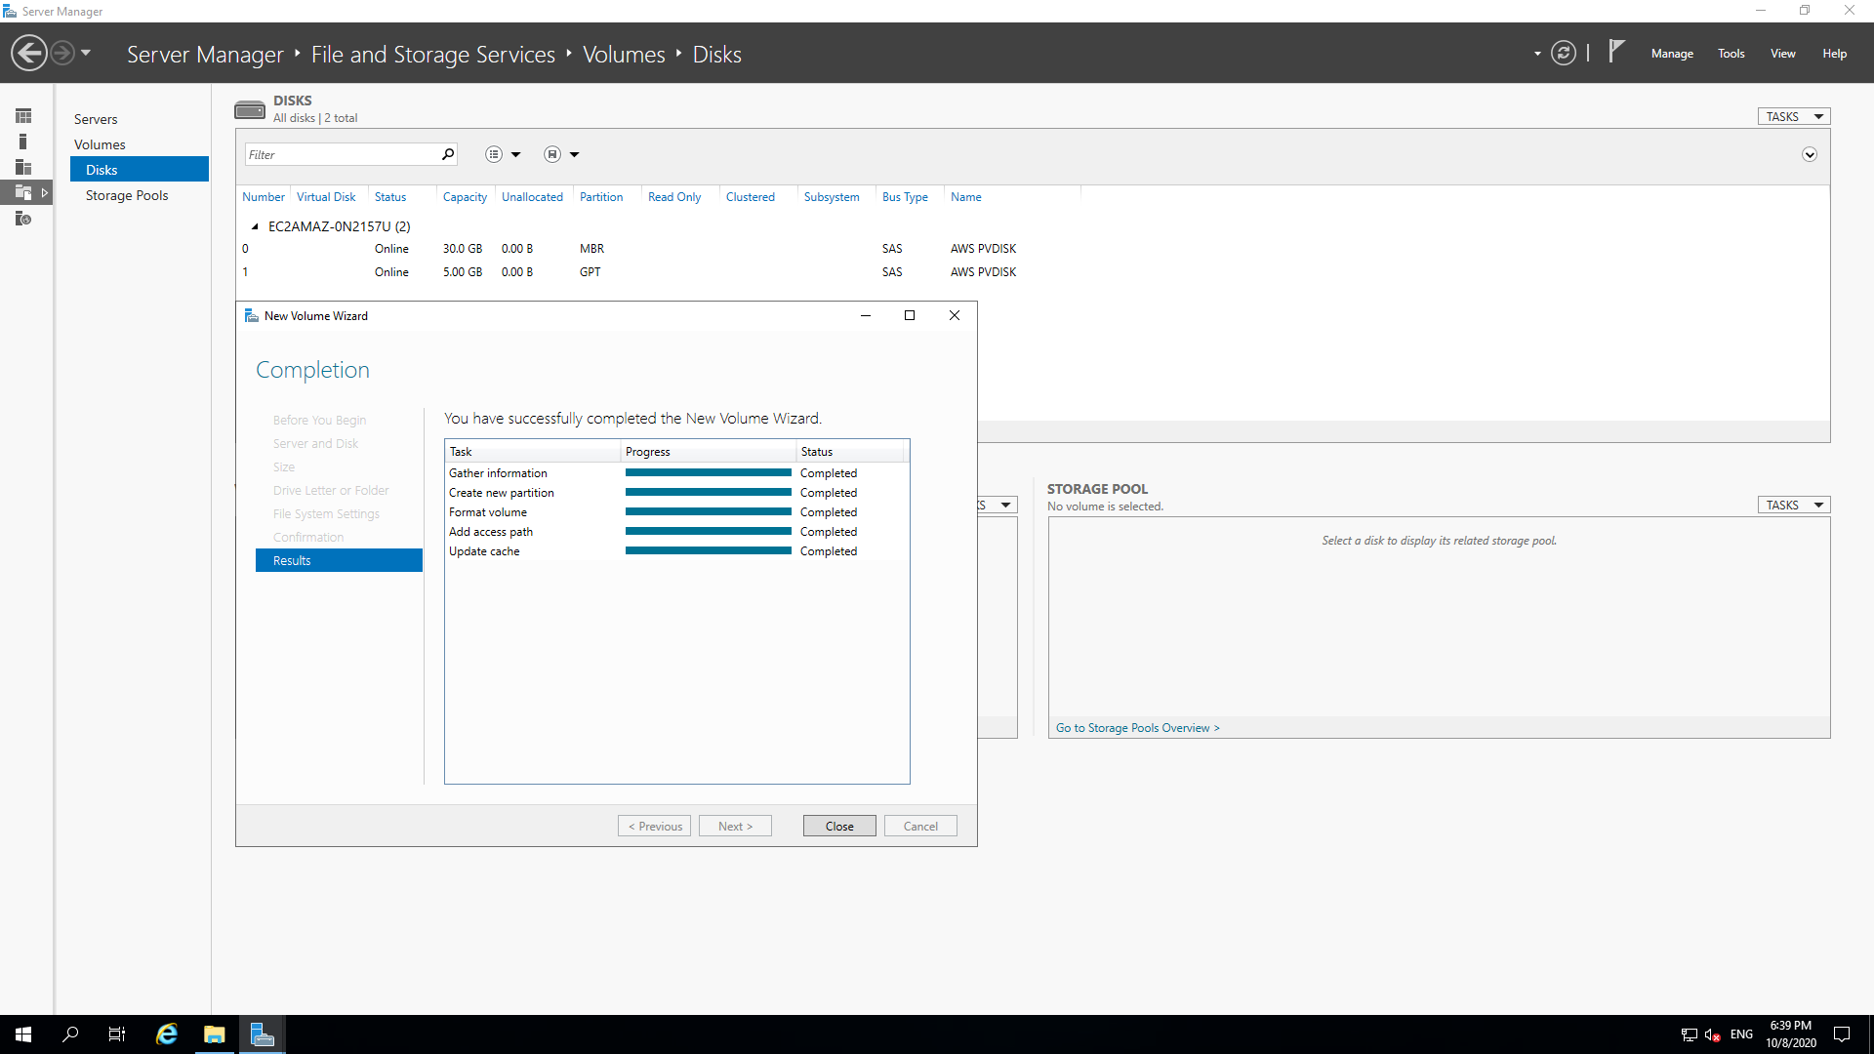

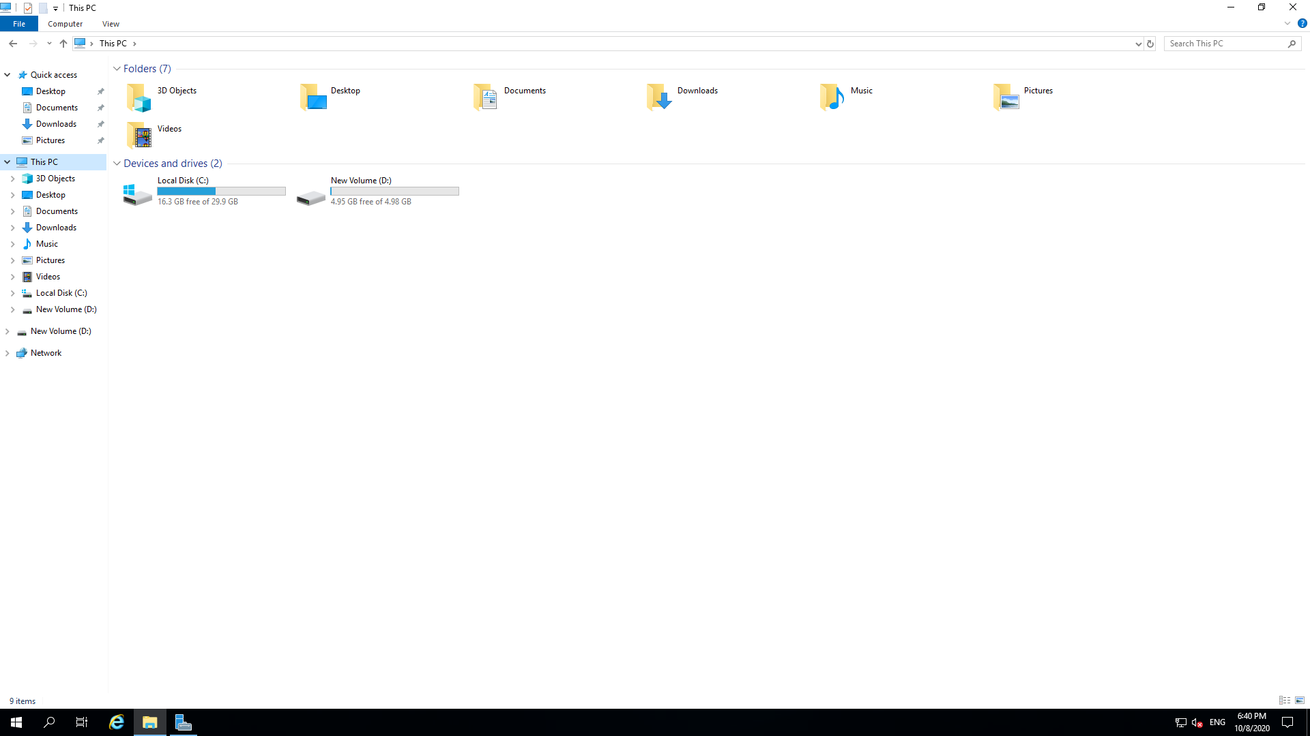

Week 2 - Day 4 – Project 4 (Elastic IPs)

Here we created Apache Tomcat Instance (54.166.186.67)

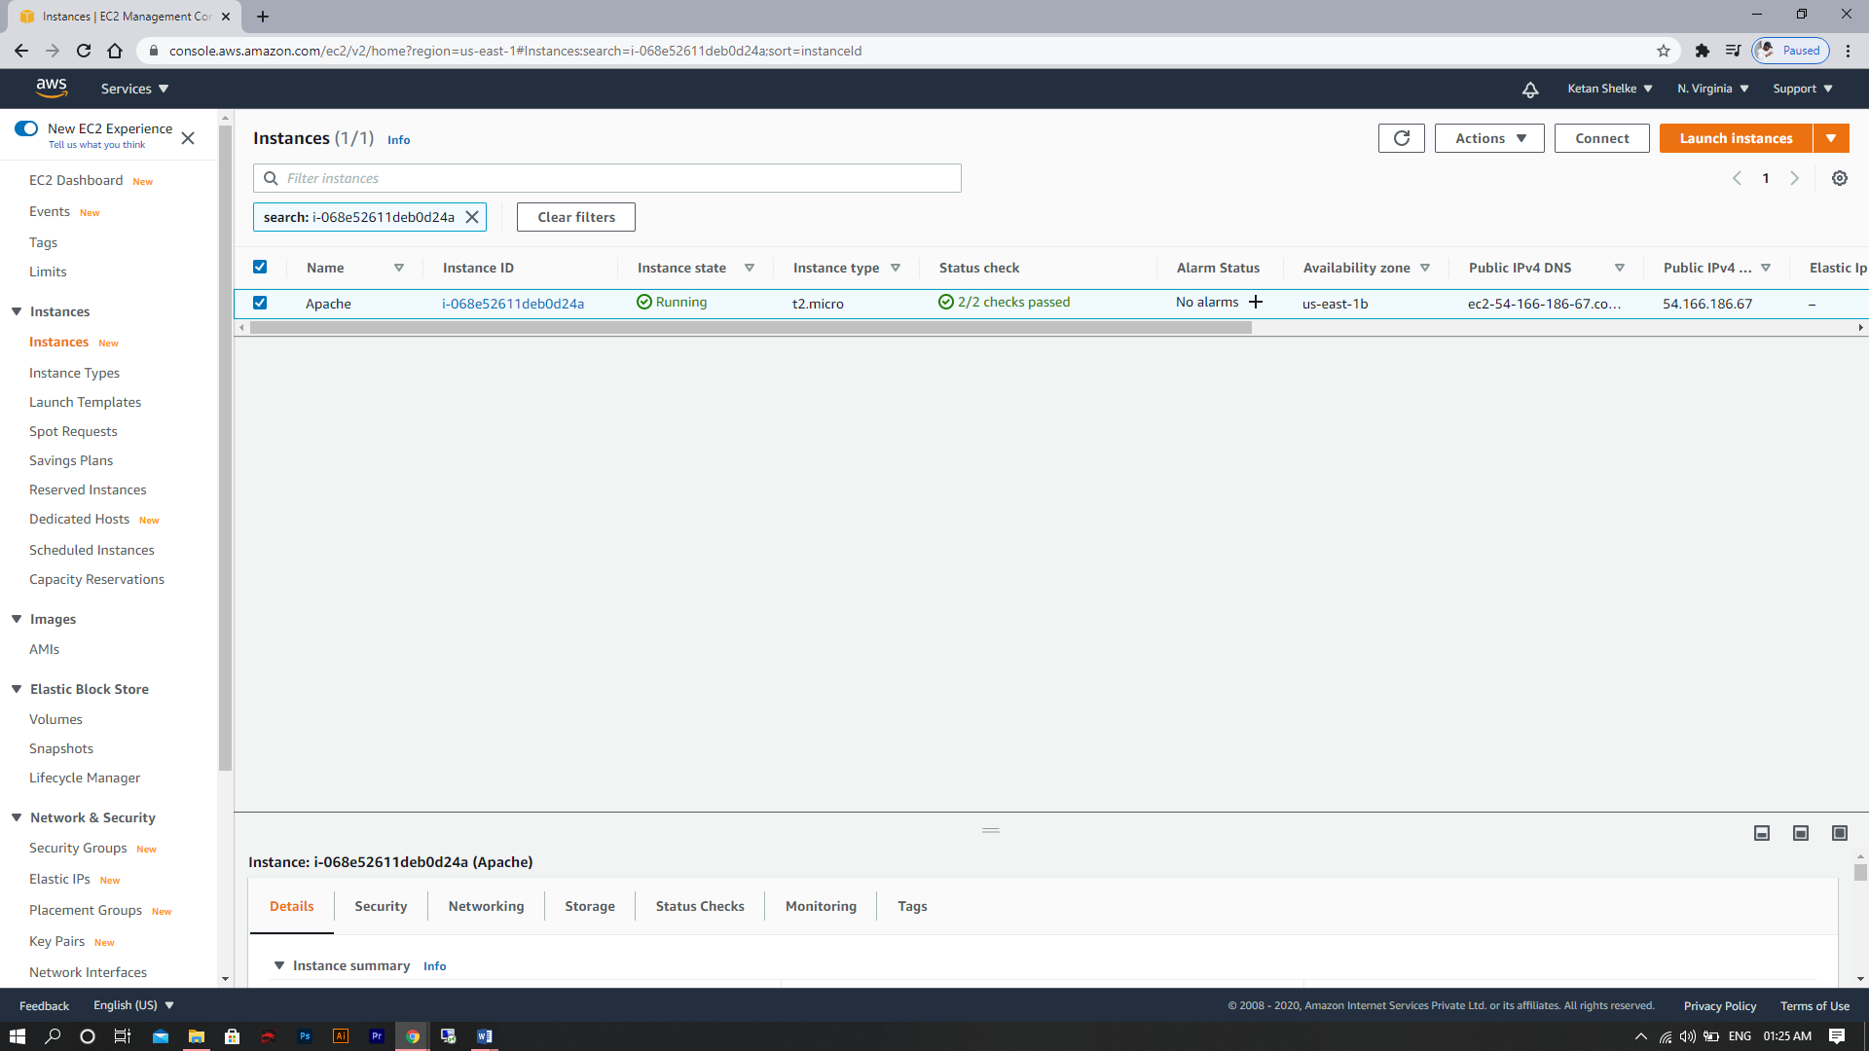

Instalation of Apache Server

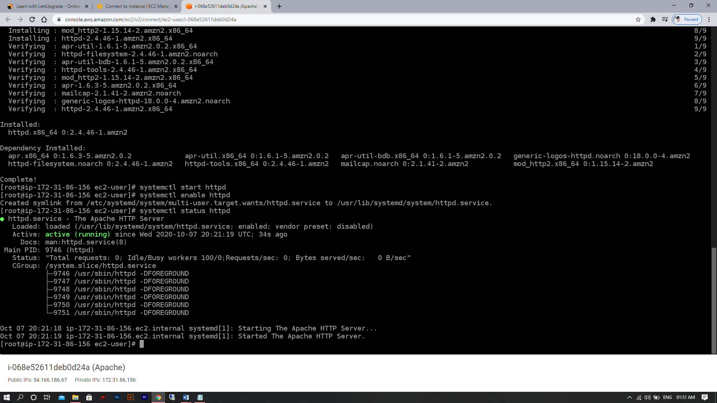

Apache Test Page

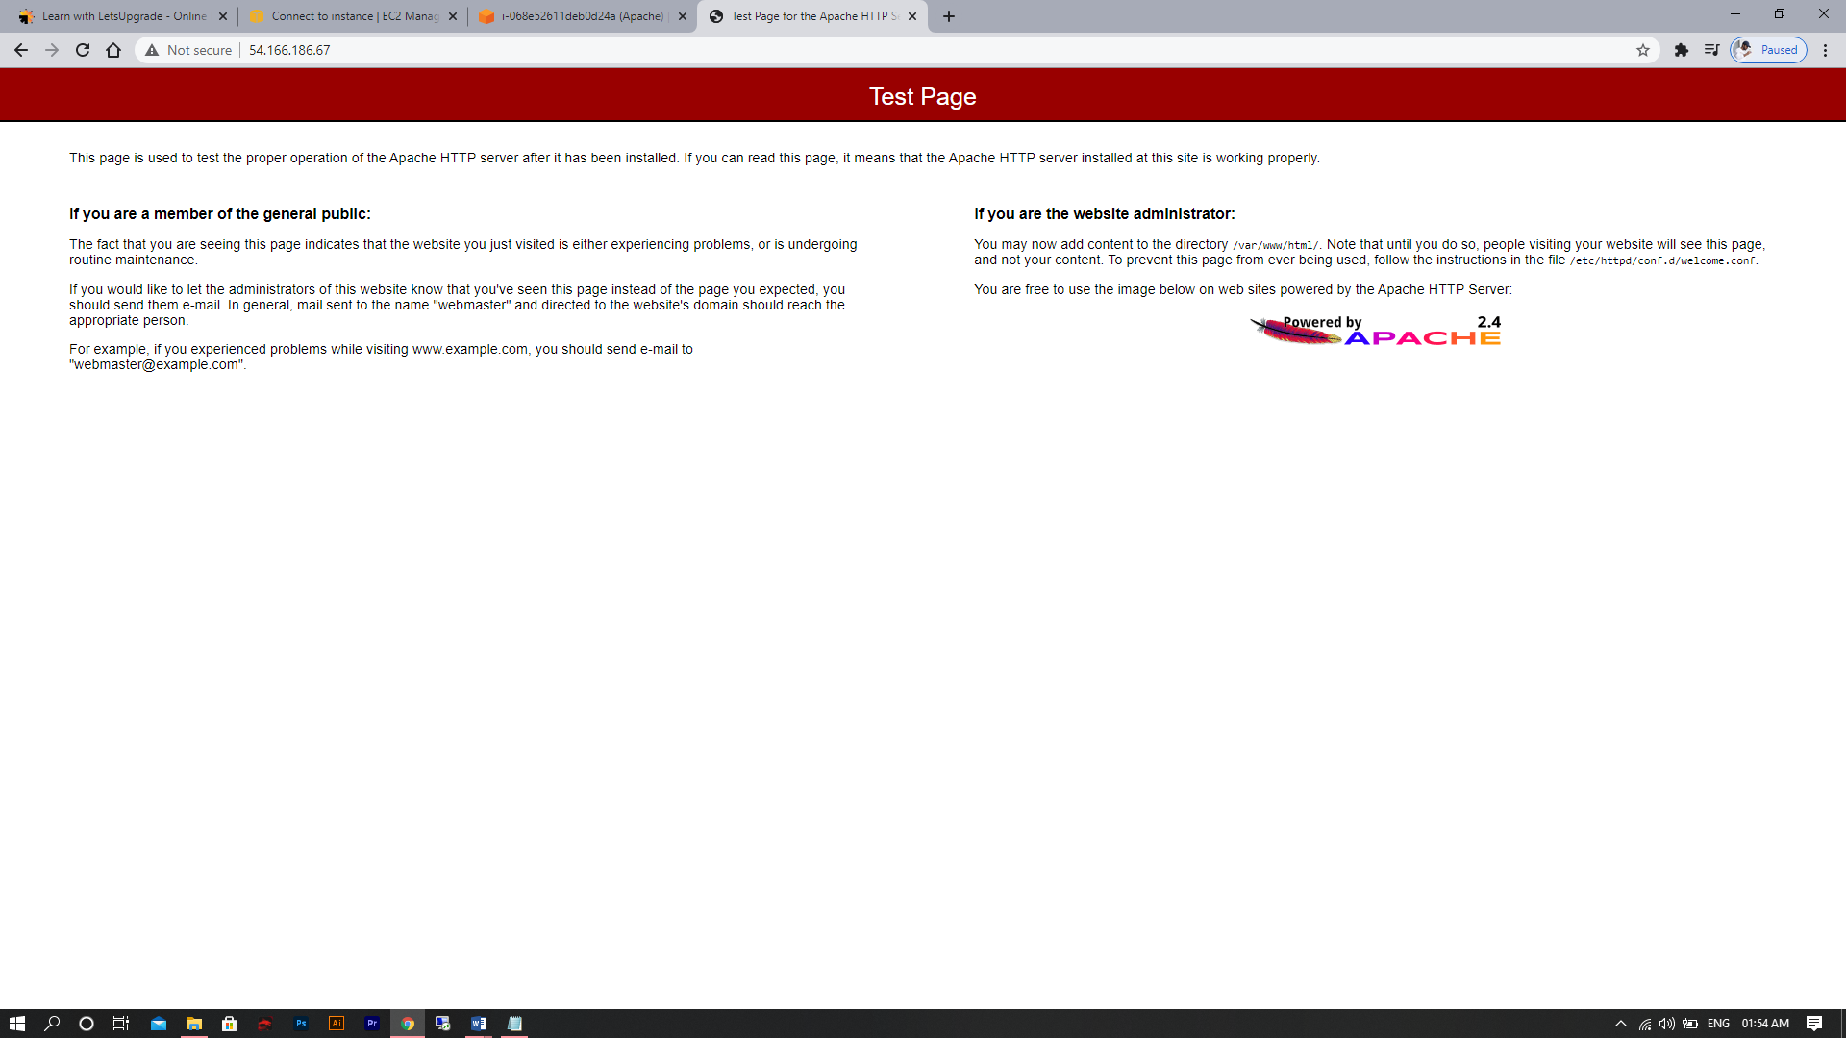

Elastic IP Address associated successfully with Apache Instance

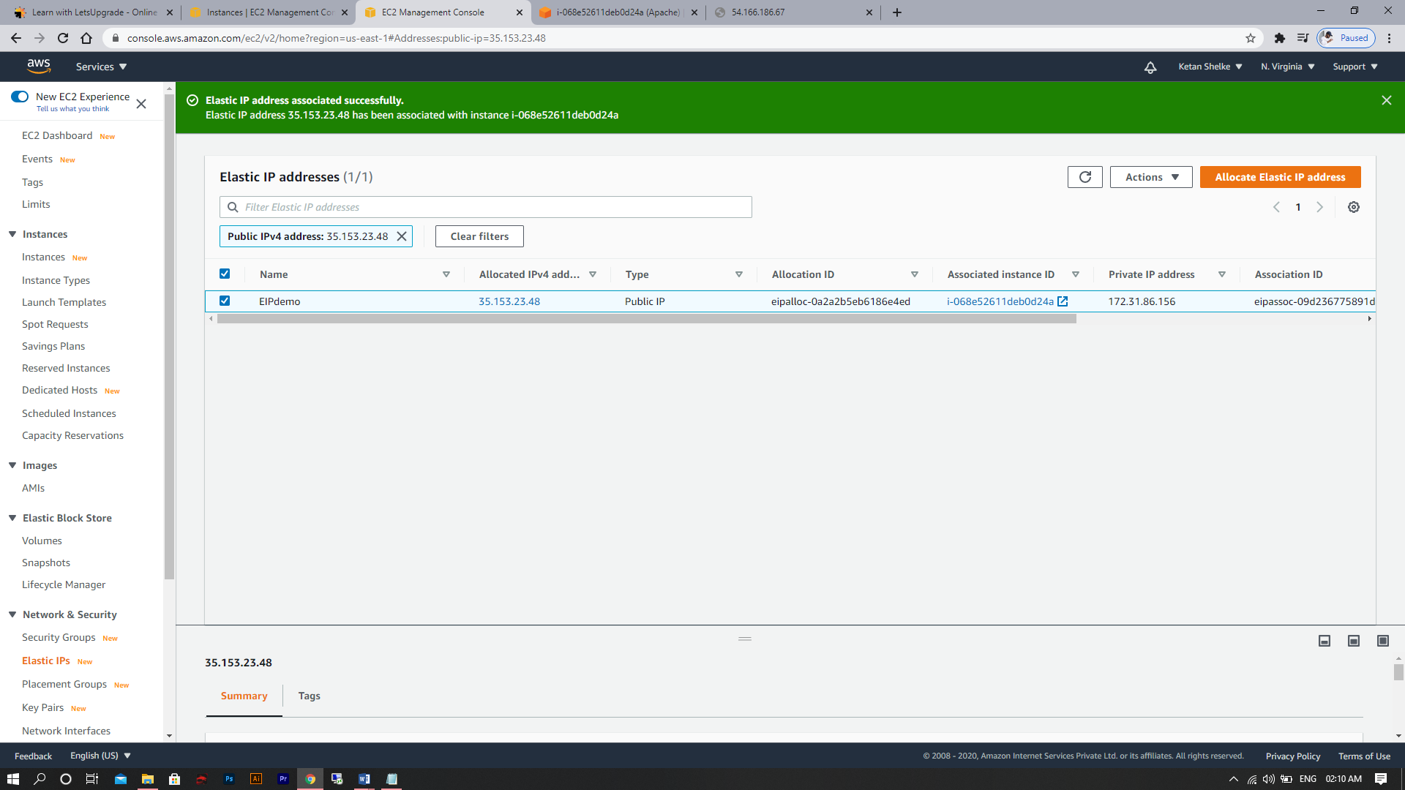

Test Page with new Elastic IP Address

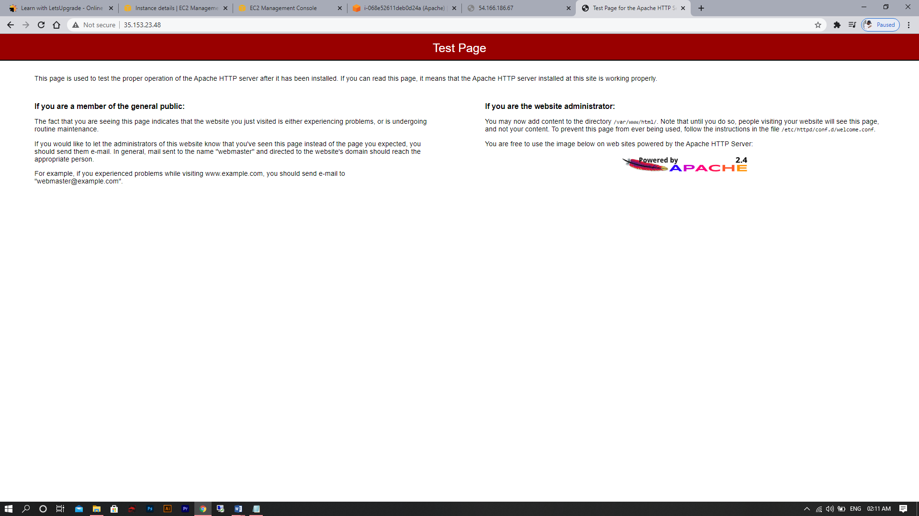

Life Cycle Effects on Instances :

1. **Start :** The instance is preparing to enter the running state. An instance enters the pending state when it launches for the first time, or when it is started after being in the stopped state.
2. **Stop :** The instance is shut down and cannot be used. The instance can be started at any time.
3. **Running :** The instance is running and ready for use.
4. **Shutting-down :** The instance is preparing to be terminated.
5. **Terminate :** The instance has been permanently deleted and cannot be started.

Week 2 - Day 4 – Project 5 (Working With S3)

Here we created two S3 Bucket

1. Day4bucket (JPG Image , Static Web Hosting)
2. Versiondemo1992 (Version demo)

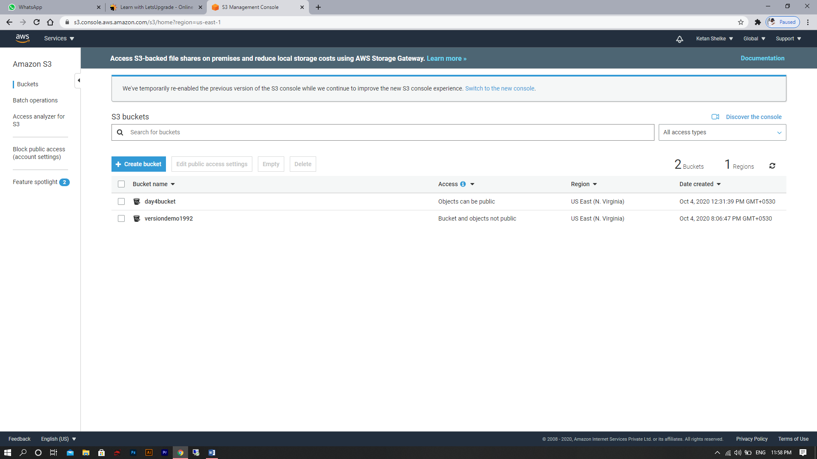

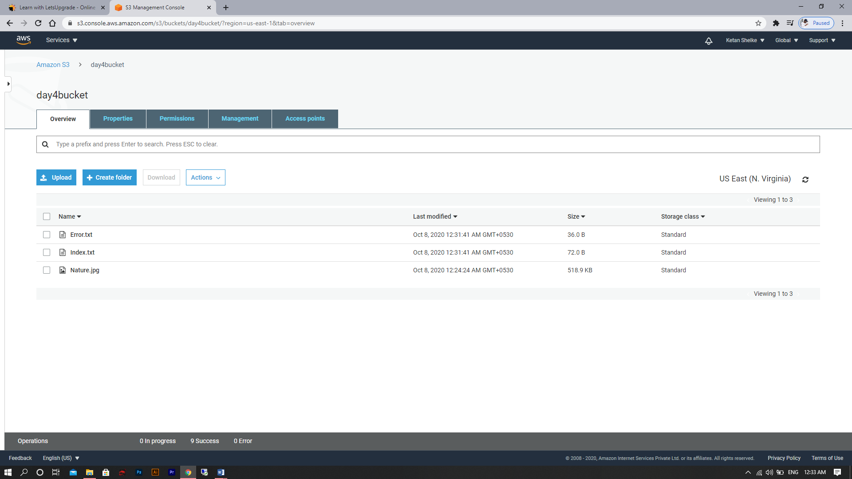

1. Working With S3 (. Jpg Image) :

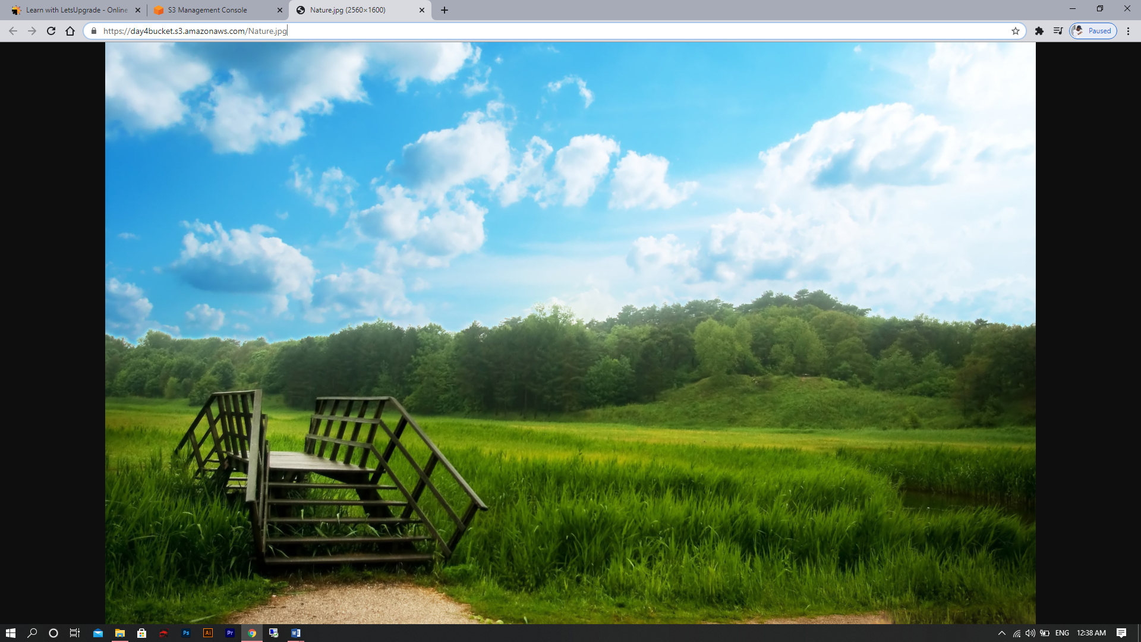

1. Static Web Hosting (Welcome Message):

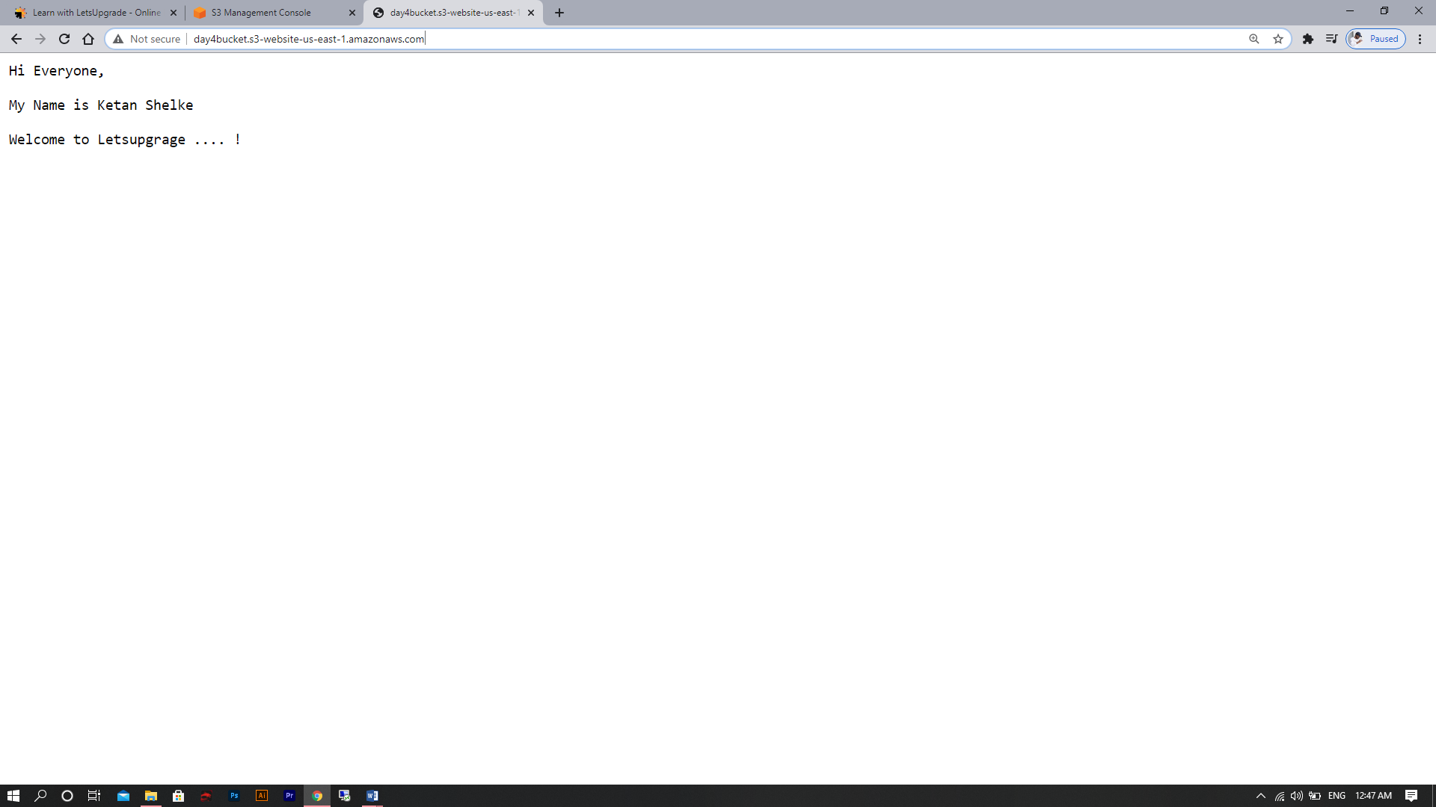

Static Web Hosting (Error Message):

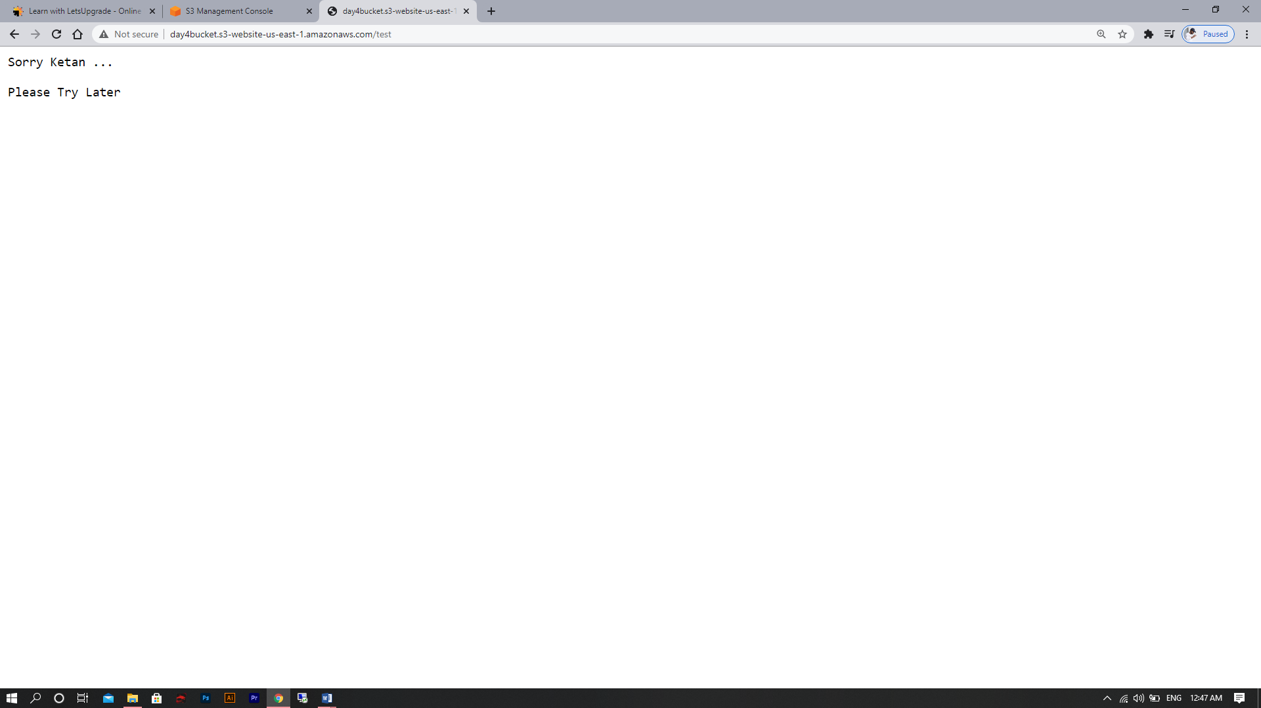

1. Versioning :

